Test Case: tc001_SPX_Dev5_Crear_Nueva_Linea_Requisicion_Spot_Tipo_Cobro_CC
Step 1 - Enter username and password and click to button Enter : Credentials Entered
Image file-name: QC_Testing-tc001_SPX_Dev5_Crear_Nueva_Linea_Requisicion_Spot_Tipo_Cobro_CC-nov. 27 2025, 07 11 42 p. m.

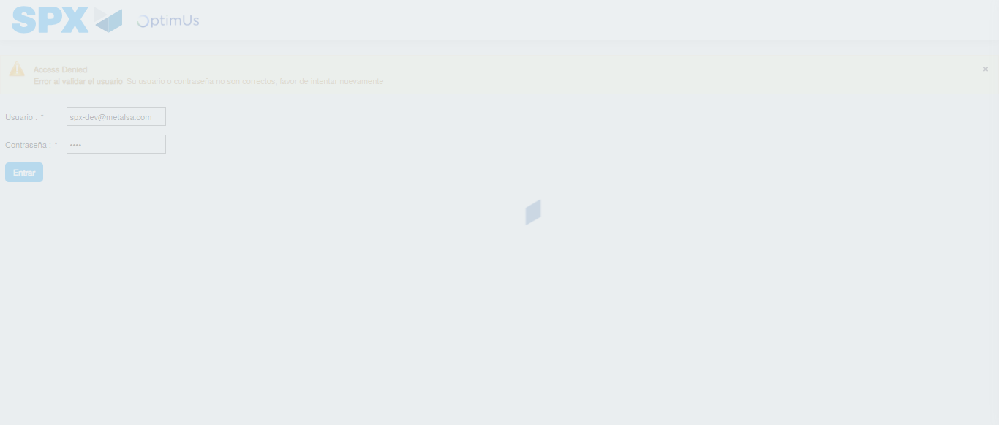Image file-name: QC_Testing-tc001_SPX_Dev5_Crear_Nueva_Linea_Requisicion_Spot_Tipo_Cobro_CC-nov. 27 2025, 07 11 43 p. m.

Step 2 - Select to UEN and Access to Spot Buy Requisitions : UEN Correctly selected and Correct access
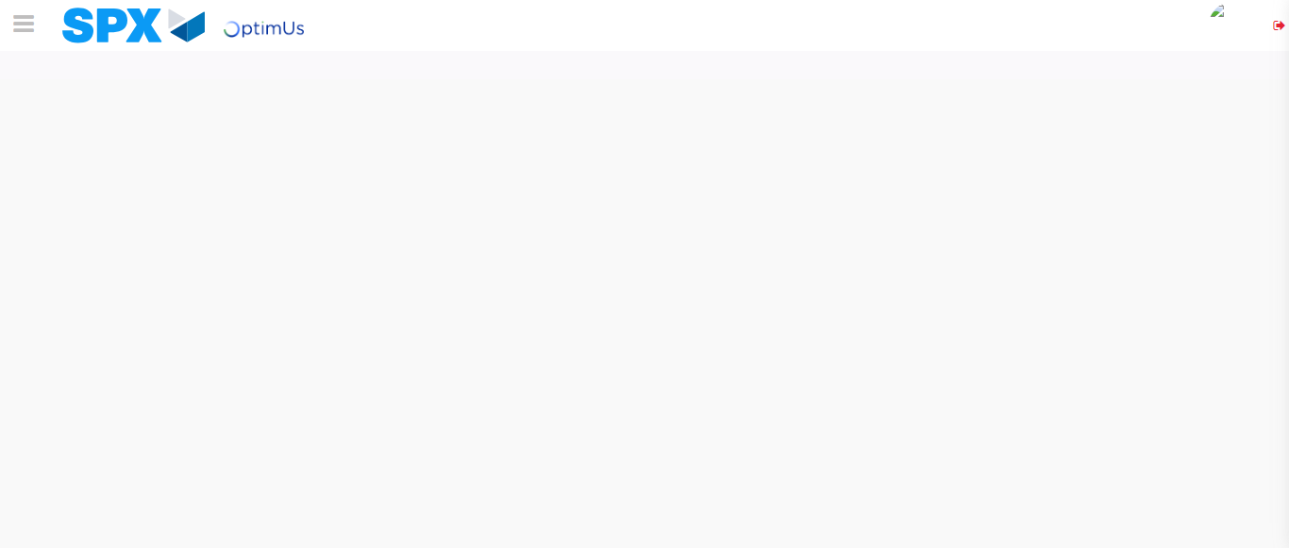Image file-name: QC_Testing-tc001_SPX_Dev5_Crear_Nueva_Linea_Requisicion_Spot_Tipo_Cobro_CC-nov. 27 2025, 07 11 46 p. m.

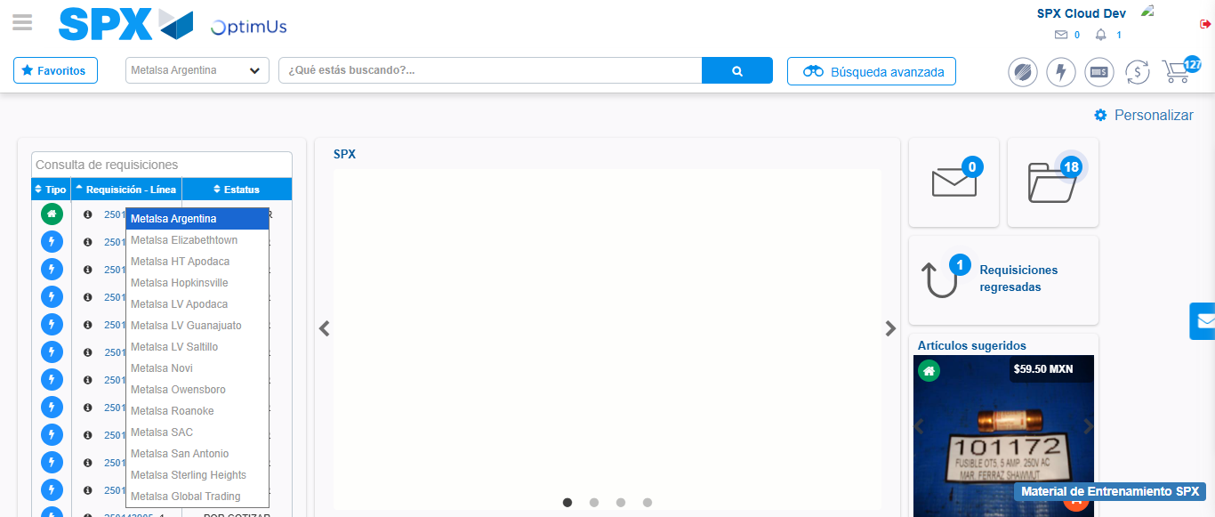Image file-name: QC_Testing-tc001_SPX_Dev5_Crear_Nueva_Linea_Requisicion_Spot_Tipo_Cobro_CC-nov. 27 2025, 07 11 48 p. m.

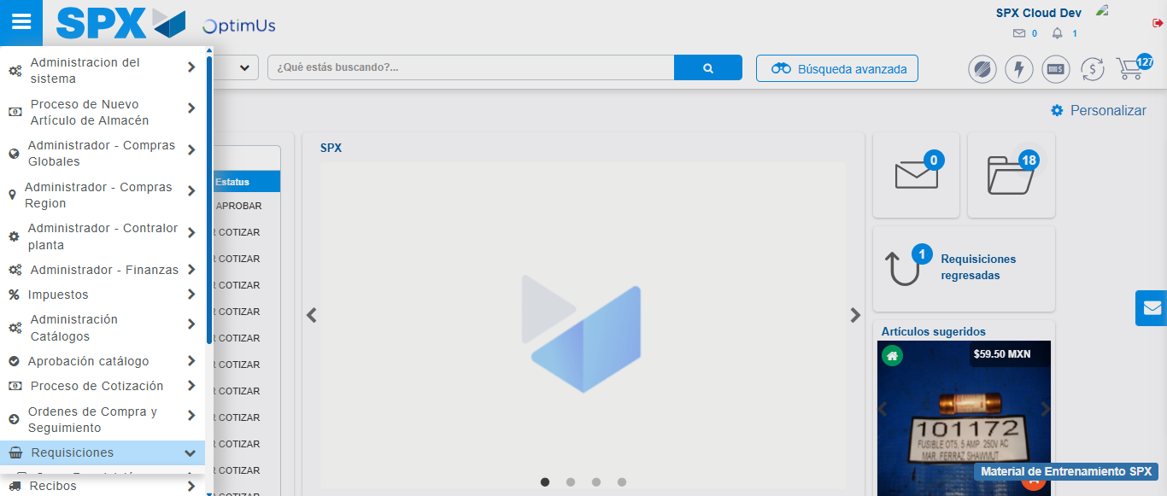Image file-name: QC_Testing-tc001_SPX_Dev5_Crear_Nueva_Linea_Requisicion_Spot_Tipo_Cobro_CC-nov. 27 2025, 07 11 49 p. m.

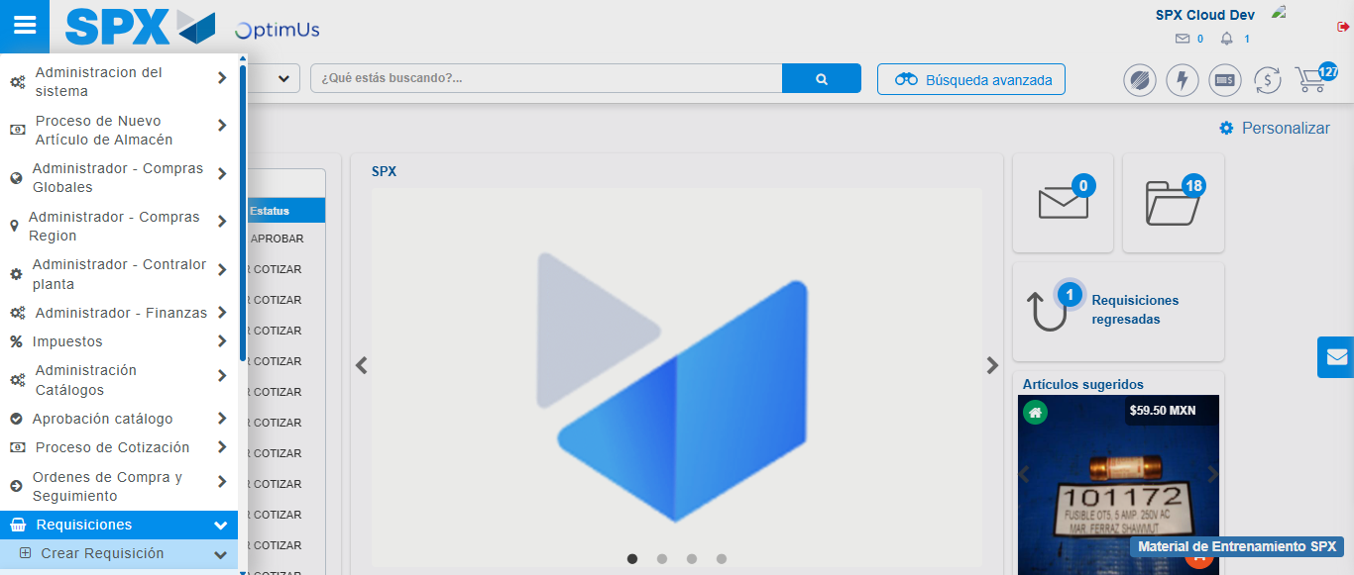Image file-name: QC_Testing-tc001_SPX_Dev5_Crear_Nueva_Linea_Requisicion_Spot_Tipo_Cobro_CC-nov. 27 2025, 07 11 50 p. m.

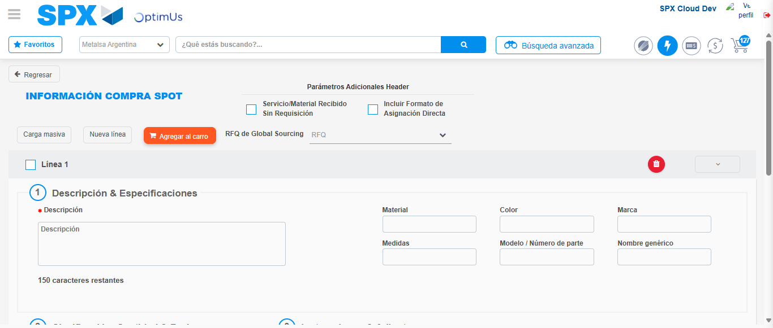Image file-name: QC_Testing-tc001_SPX_Dev5_Crear_Nueva_Linea_Requisicion_Spot_Tipo_Cobro_CC-nov. 27 2025, 07 11 53 p. m.

Step 3 - Data Capture Spot Buy Requisition: Data captured correctly
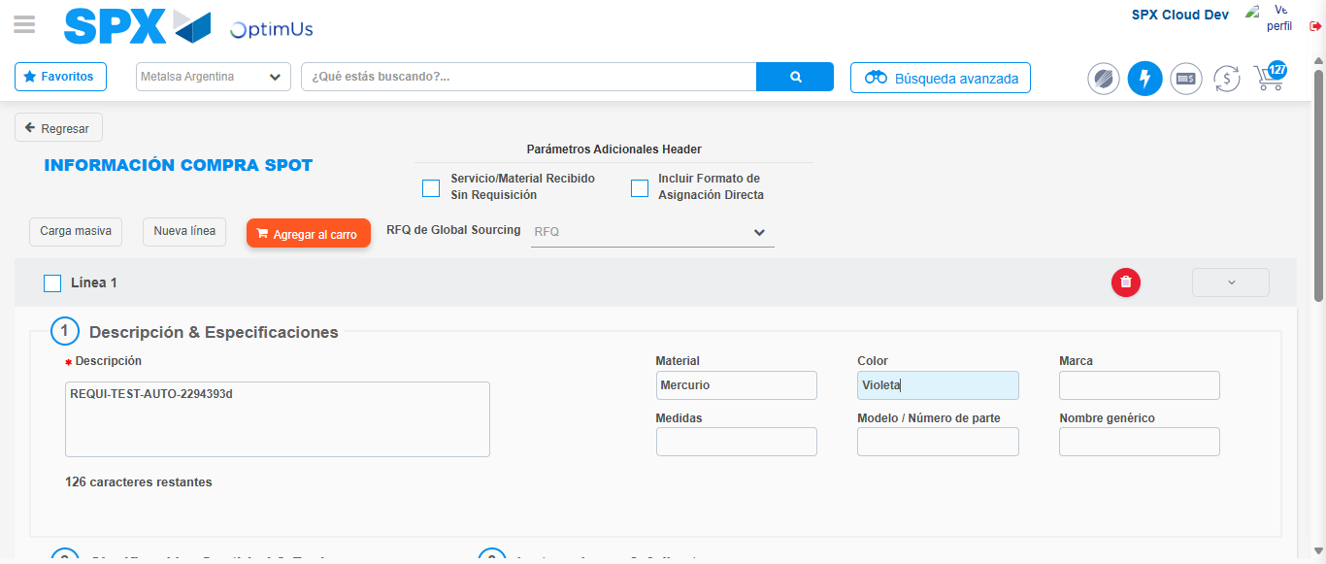Image file-name: QC_Testing-tc001_SPX_Dev5_Crear_Nueva_Linea_Requisicion_Spot_Tipo_Cobro_CC-nov. 27 2025, 07 11 54 p. m.

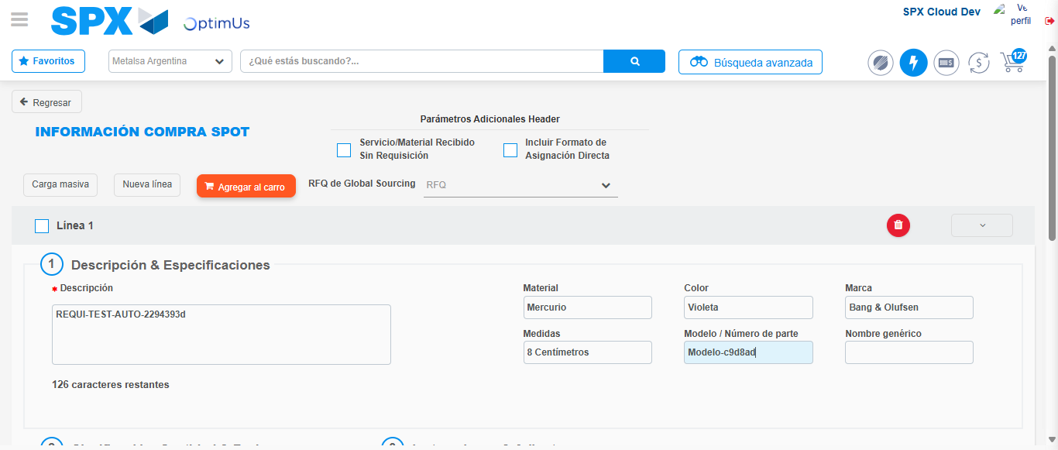Image file-name: QC_Testing-tc001_SPX_Dev5_Crear_Nueva_Linea_Requisicion_Spot_Tipo_Cobro_CC-nov. 27 2025, 07 11 55 p. m.

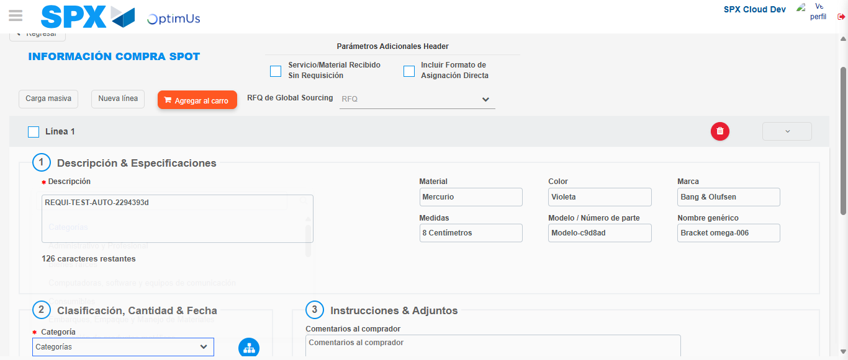Image file-name: QC_Testing-tc001_SPX_Dev5_Crear_Nueva_Linea_Requisicion_Spot_Tipo_Cobro_CC-nov. 27 2025, 07 11 56 p. m.

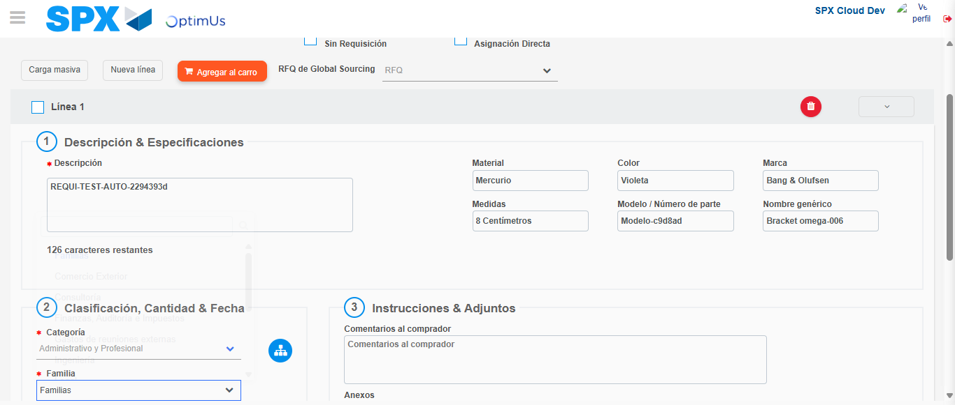Image file-name: QC_Testing-tc001_SPX_Dev5_Crear_Nueva_Linea_Requisicion_Spot_Tipo_Cobro_CC-nov. 27 2025, 07 11 57 p. m.

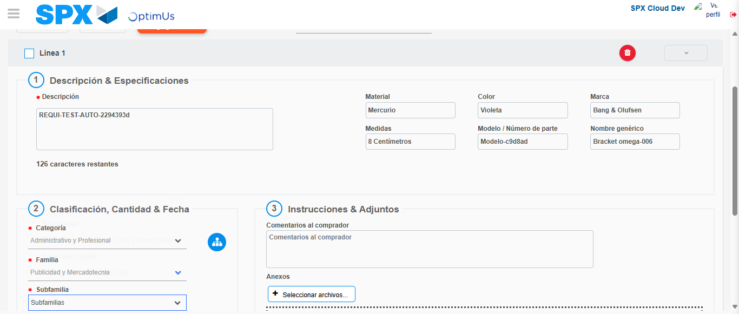Image file-name: QC_Testing-tc001_SPX_Dev5_Crear_Nueva_Linea_Requisicion_Spot_Tipo_Cobro_CC-nov. 27 2025, 07 11 58 p. m.

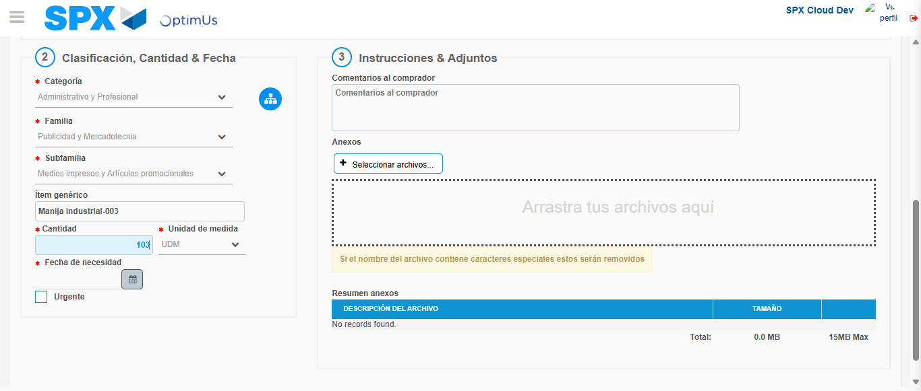Image file-name: QC_Testing-tc001_SPX_Dev5_Crear_Nueva_Linea_Requisicion_Spot_Tipo_Cobro_CC-nov. 27 2025, 07 11 59 p. m.

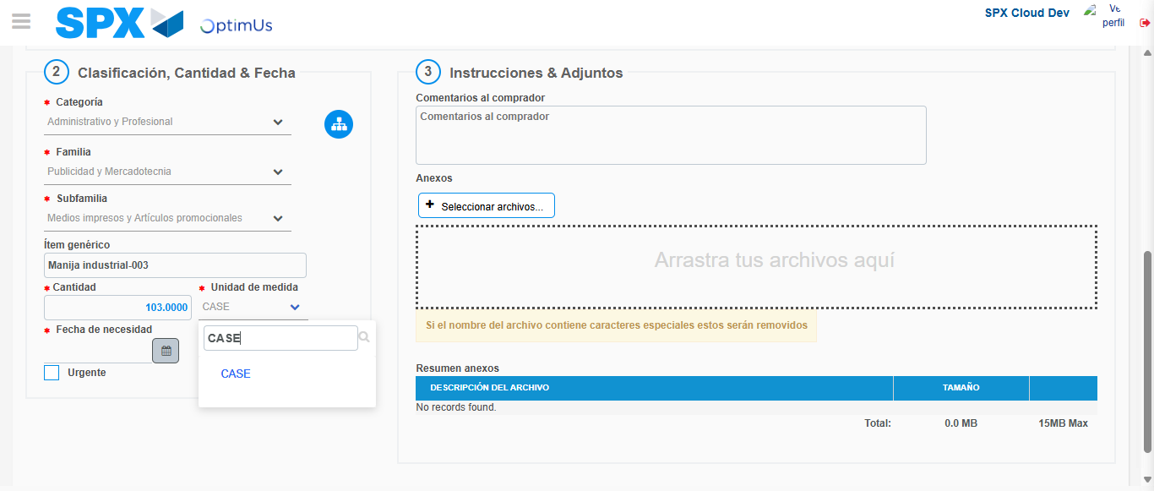Image file-name: QC_Testing-tc001_SPX_Dev5_Crear_Nueva_Linea_Requisicion_Spot_Tipo_Cobro_CC-nov. 27 2025, 07 12 00 p. m.

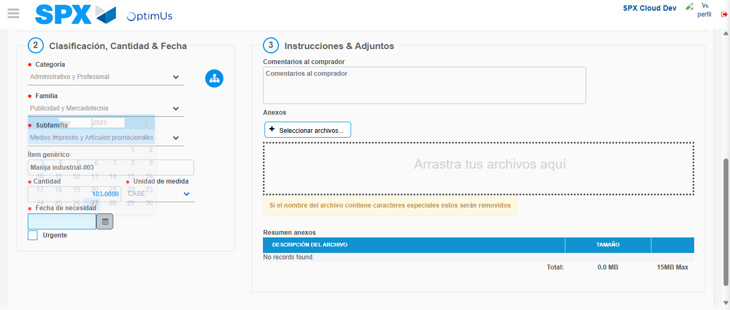Image file-name: QC_Testing-tc001_SPX_Dev5_Crear_Nueva_Linea_Requisicion_Spot_Tipo_Cobro_CC-nov. 27 2025, 07 12 01 p. m.

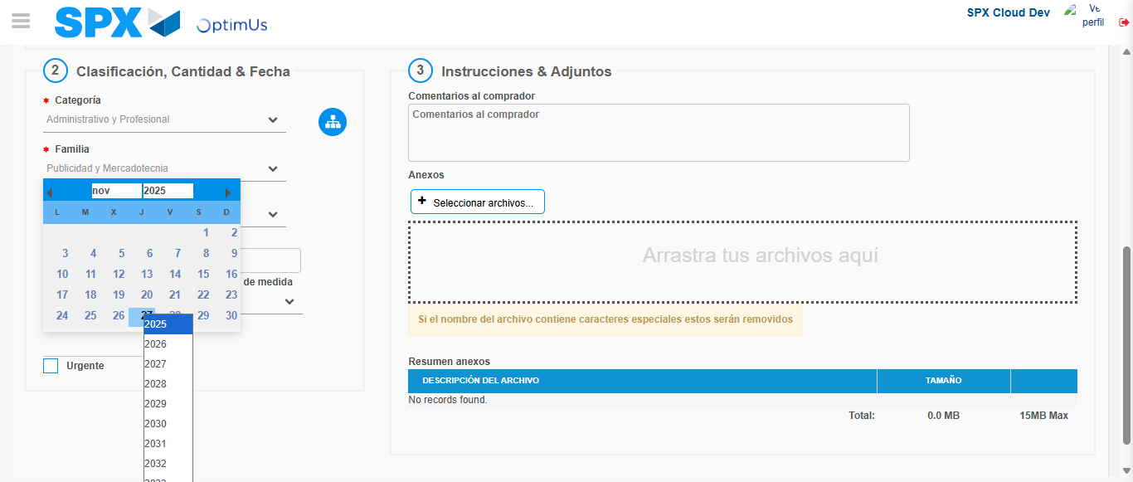Image file-name: QC_Testing-tc001_SPX_Dev5_Crear_Nueva_Linea_Requisicion_Spot_Tipo_Cobro_CC-nov. 27 2025, 07 12 02 p. m.

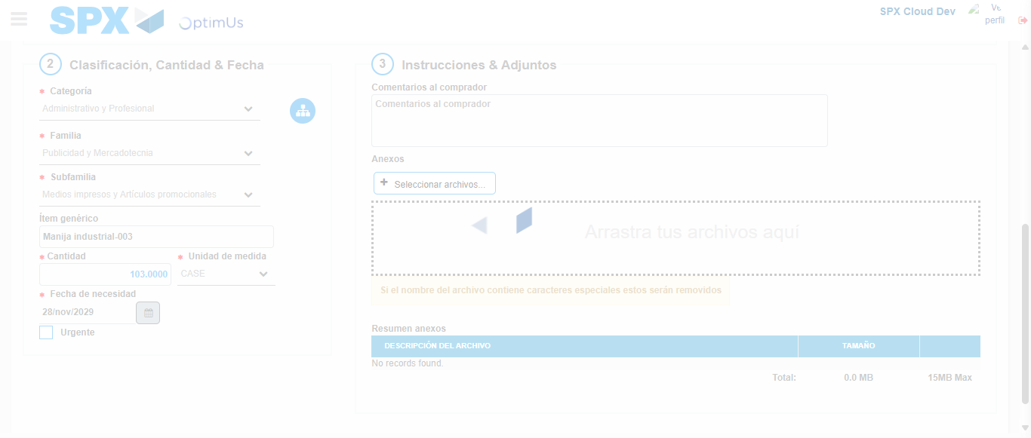Image file-name: QC_Testing-tc001_SPX_Dev5_Crear_Nueva_Linea_Requisicion_Spot_Tipo_Cobro_CC-nov. 27 2025, 07 12 03 p. m.

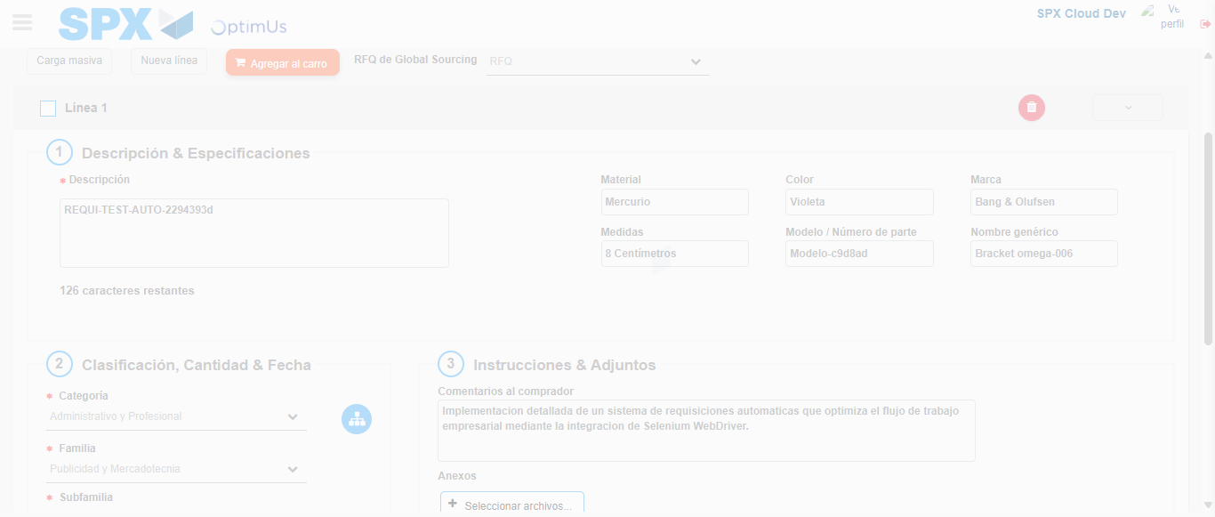Image file-name: QC_Testing-tc001_SPX_Dev5_Crear_Nueva_Linea_Requisicion_Spot_Tipo_Cobro_CC-nov. 27 2025, 07 12 04 p. m.

Step 4 - Add new line and data capture second line: Line add correctly
Image file-name: QC_Testing-tc001_SPX_Dev5_Crear_Nueva_Linea_Requisicion_Spot_Tipo_Cobro_CC-nov. 27 2025, 07 11 54 p. m.

Image file-name: QC_Testing-tc001_SPX_Dev5_Crear_Nueva_Linea_Requisicion_Spot_Tipo_Cobro_CC-nov. 27 2025, 07 11 55 p. m.

Image file-name: QC_Testing-tc001_SPX_Dev5_Crear_Nueva_Linea_Requisicion_Spot_Tipo_Cobro_CC-nov. 27 2025, 07 11 56 p. m.

Image file-name: QC_Testing-tc001_SPX_Dev5_Crear_Nueva_Linea_Requisicion_Spot_Tipo_Cobro_CC-nov. 27 2025, 07 11 57 p. m.

Image file-name: QC_Testing-tc001_SPX_Dev5_Crear_Nueva_Linea_Requisicion_Spot_Tipo_Cobro_CC-nov. 27 2025, 07 11 58 p. m.

Image file-name: QC_Testing-tc001_SPX_Dev5_Crear_Nueva_Linea_Requisicion_Spot_Tipo_Cobro_CC-nov. 27 2025, 07 11 59 p. m.

Image file-name: QC_Testing-tc001_SPX_Dev5_Crear_Nueva_Linea_Requisicion_Spot_Tipo_Cobro_CC-nov. 27 2025, 07 12 00 p. m.

Image file-name: QC_Testing-tc001_SPX_Dev5_Crear_Nueva_Linea_Requisicion_Spot_Tipo_Cobro_CC-nov. 27 2025, 07 12 01 p. m.

Image file-name: QC_Testing-tc001_SPX_Dev5_Crear_Nueva_Linea_Requisicion_Spot_Tipo_Cobro_CC-nov. 27 2025, 07 12 02 p. m.

Image file-name: QC_Testing-tc001_SPX_Dev5_Crear_Nueva_Linea_Requisicion_Spot_Tipo_Cobro_CC-nov. 27 2025, 07 12 03 p. m.

Image file-name: QC_Testing-tc001_SPX_Dev5_Crear_Nueva_Linea_Requisicion_Spot_Tipo_Cobro_CC-nov. 27 2025, 07 12 04 p. m.

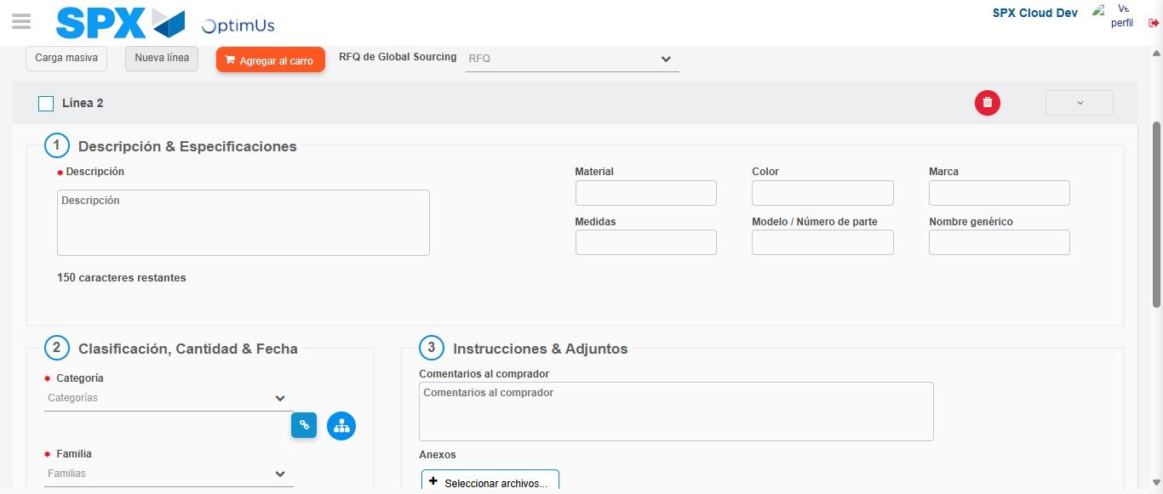Image file-name: QC_Testing-tc001_SPX_Dev5_Crear_Nueva_Linea_Requisicion_Spot_Tipo_Cobro_CC-nov. 27 2025, 07 12 07 p. m.

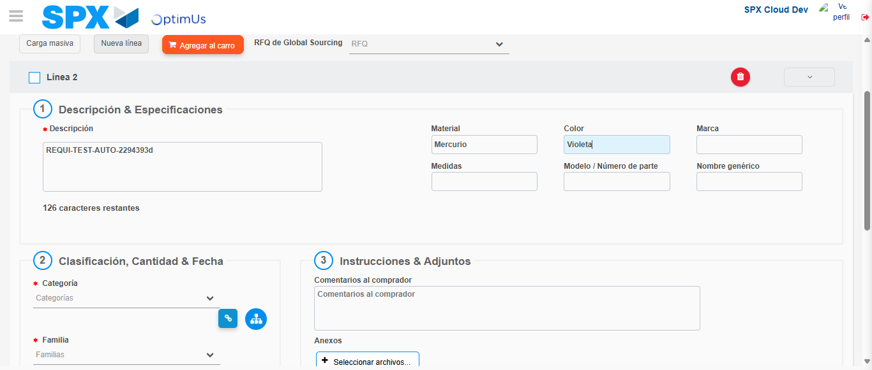Image file-name: QC_Testing-tc001_SPX_Dev5_Crear_Nueva_Linea_Requisicion_Spot_Tipo_Cobro_CC-nov. 27 2025, 07 12 08 p. m.

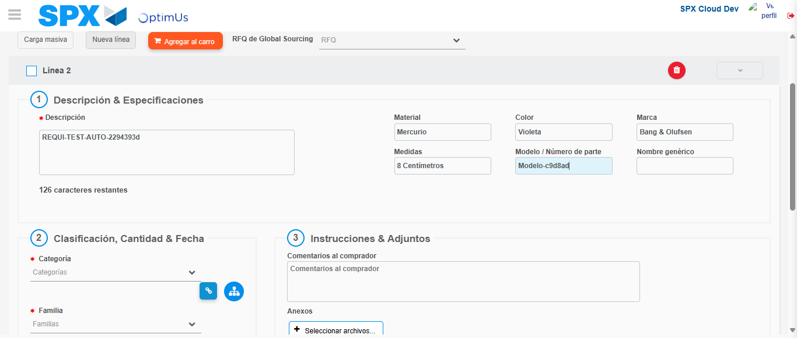Image file-name: QC_Testing-tc001_SPX_Dev5_Crear_Nueva_Linea_Requisicion_Spot_Tipo_Cobro_CC-nov. 27 2025, 07 12 09 p. m.

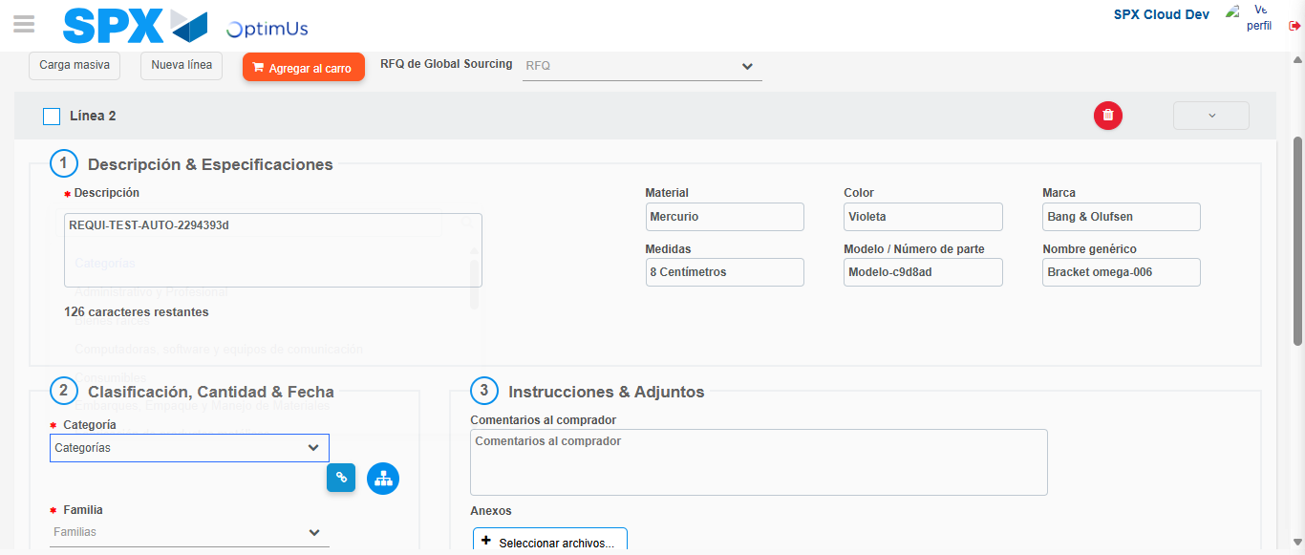Image file-name: QC_Testing-tc001_SPX_Dev5_Crear_Nueva_Linea_Requisicion_Spot_Tipo_Cobro_CC-nov. 27 2025, 07 12 10 p. m.

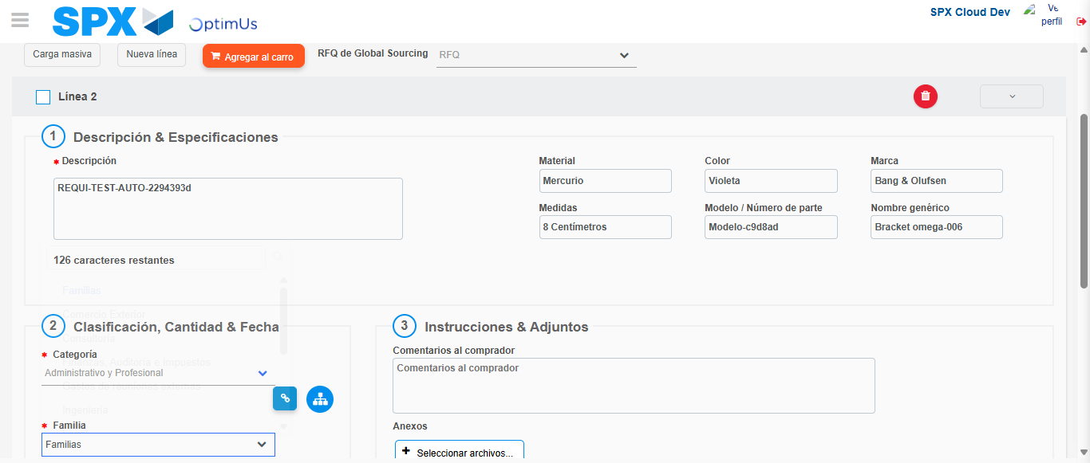Image file-name: QC_Testing-tc001_SPX_Dev5_Crear_Nueva_Linea_Requisicion_Spot_Tipo_Cobro_CC-nov. 27 2025, 07 12 11 p. m.

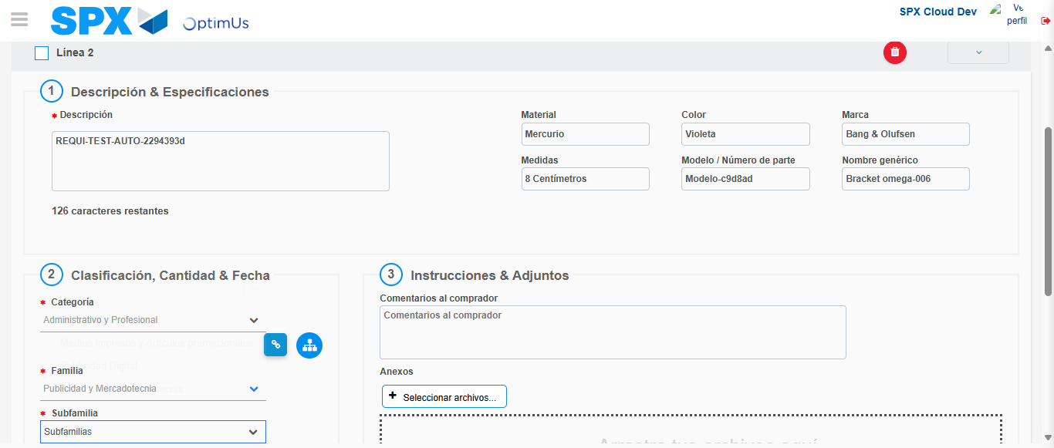Image file-name: QC_Testing-tc001_SPX_Dev5_Crear_Nueva_Linea_Requisicion_Spot_Tipo_Cobro_CC-nov. 27 2025, 07 12 12 p. m.

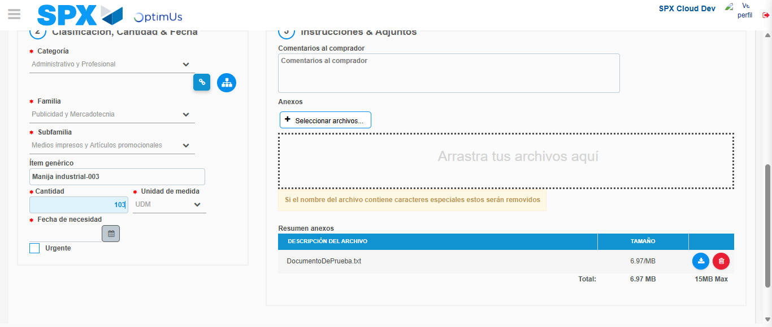Image file-name: QC_Testing-tc001_SPX_Dev5_Crear_Nueva_Linea_Requisicion_Spot_Tipo_Cobro_CC-nov. 27 2025, 07 12 13 p. m.

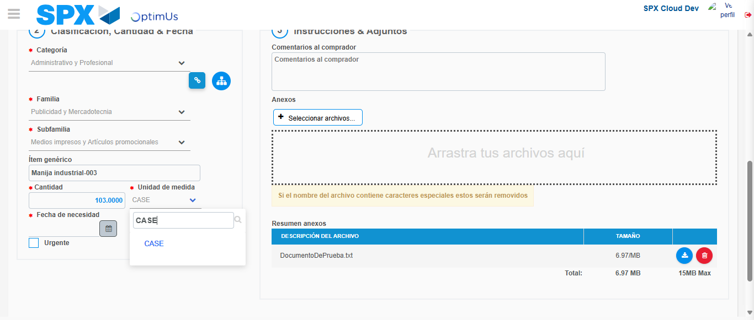Image file-name: QC_Testing-tc001_SPX_Dev5_Crear_Nueva_Linea_Requisicion_Spot_Tipo_Cobro_CC-nov. 27 2025, 07 12 14 p. m.

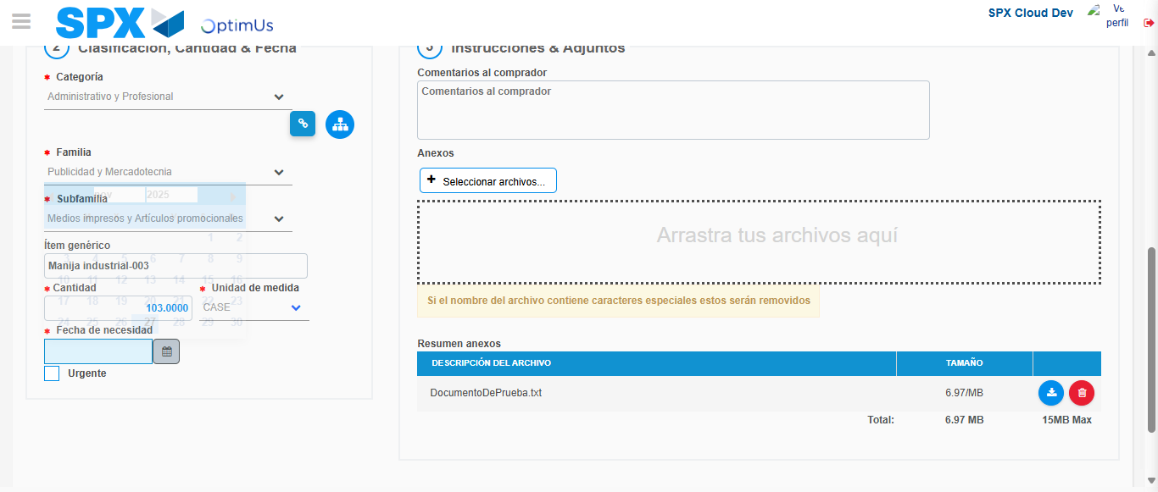Image file-name: QC_Testing-tc001_SPX_Dev5_Crear_Nueva_Linea_Requisicion_Spot_Tipo_Cobro_CC-nov. 27 2025, 07 12 15 p. m.

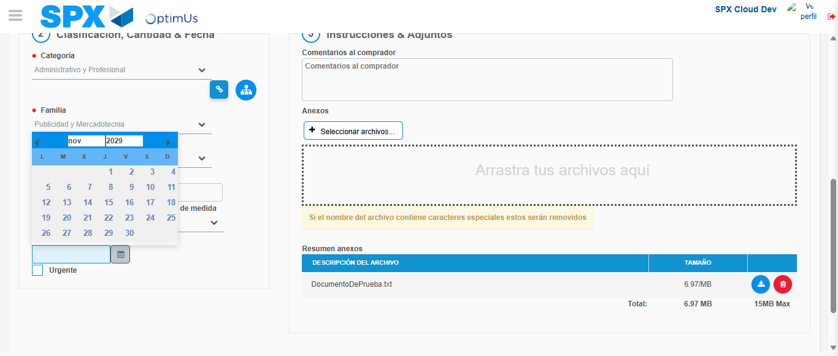Image file-name: QC_Testing-tc001_SPX_Dev5_Crear_Nueva_Linea_Requisicion_Spot_Tipo_Cobro_CC-nov. 27 2025, 07 12 16 p. m.

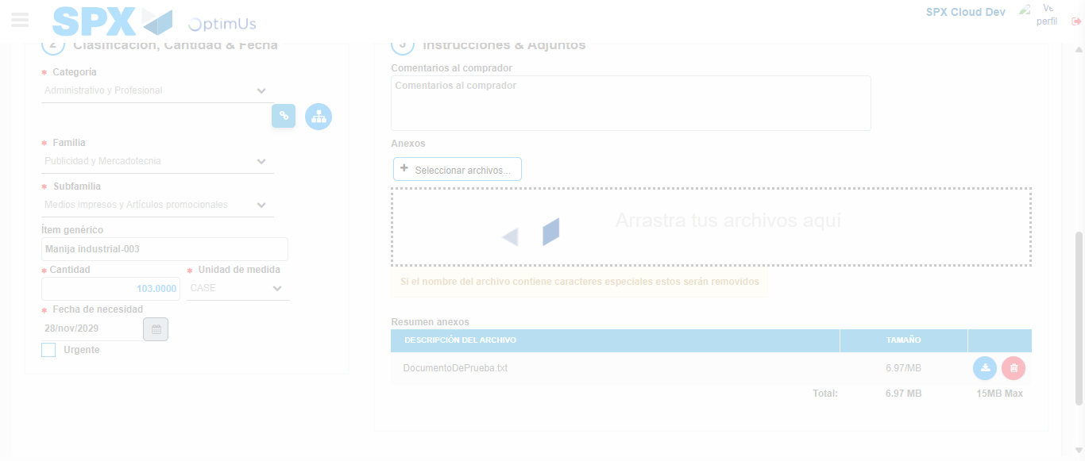Image file-name: QC_Testing-tc001_SPX_Dev5_Crear_Nueva_Linea_Requisicion_Spot_Tipo_Cobro_CC-nov. 27 2025, 07 12 17 p. m.

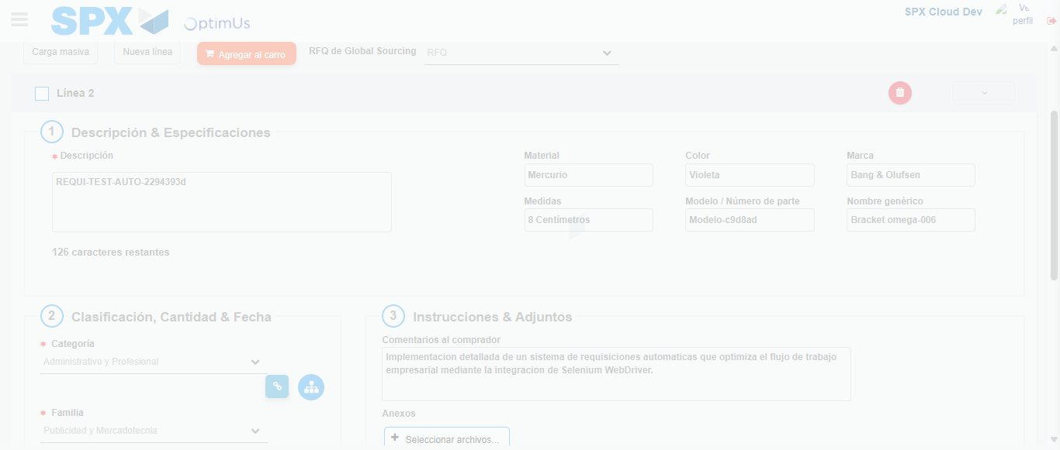Image file-name: QC_Testing-tc001_SPX_Dev5_Crear_Nueva_Linea_Requisicion_Spot_Tipo_Cobro_CC-nov. 27 2025, 07 12 18 p. m.

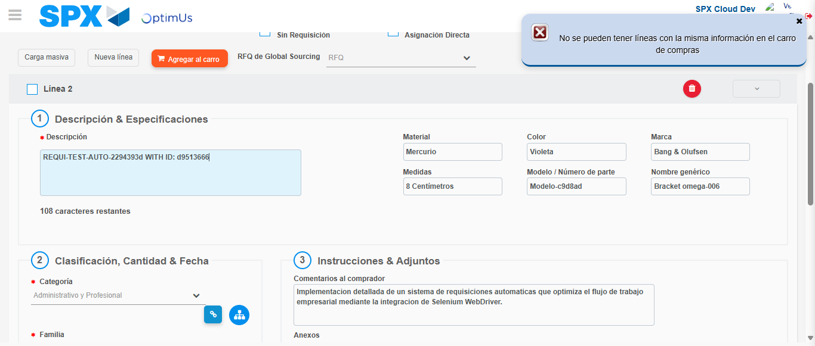Image file-name: QC_Testing-tc001_SPX_Dev5_Crear_Nueva_Linea_Requisicion_Spot_Tipo_Cobro_CC-nov. 27 2025, 07 12 21 p. m.

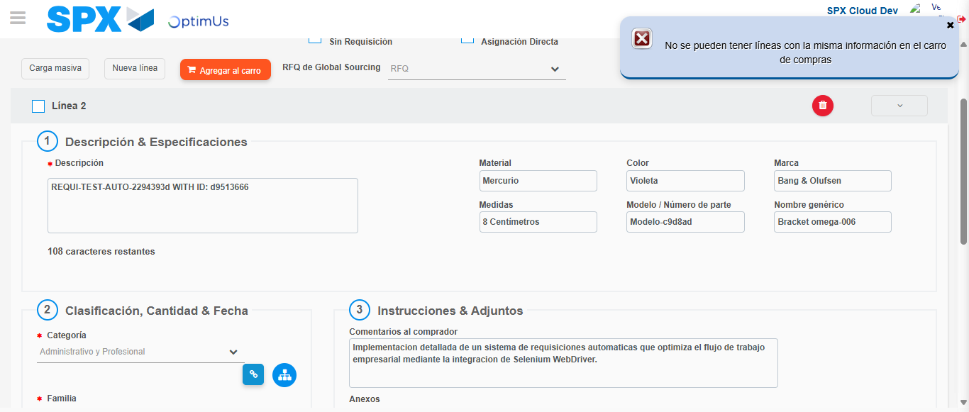Image file-name: QC_Testing-tc001_SPX_Dev5_Crear_Nueva_Linea_Requisicion_Spot_Tipo_Cobro_CC-nov. 27 2025, 07 12 22 p. m.

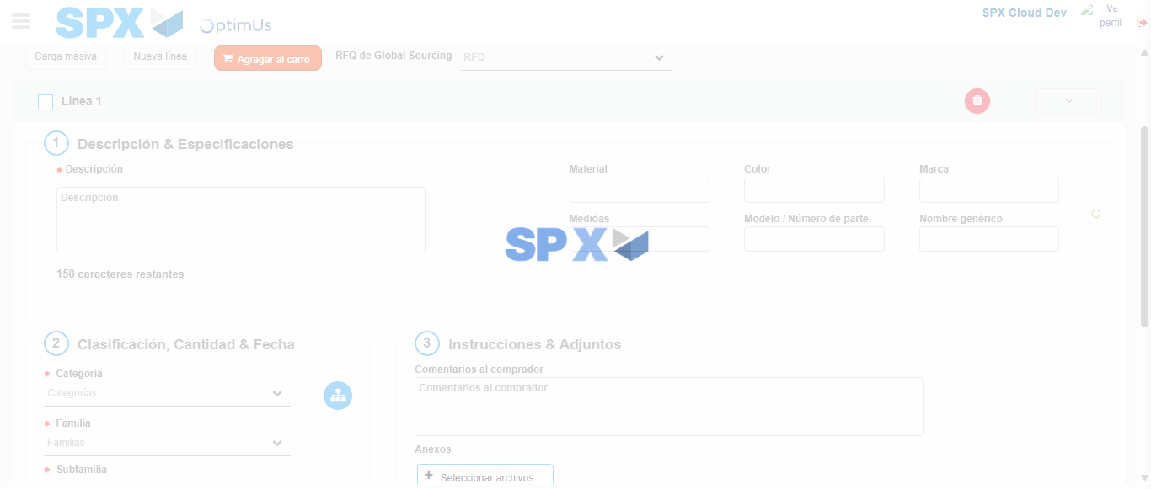Image file-name: QC_Testing-tc001_SPX_Dev5_Crear_Nueva_Linea_Requisicion_Spot_Tipo_Cobro_CC-nov. 27 2025, 07 12 25 p. m.

Step 5 - Select to Requisition: Requisition Correctly selected
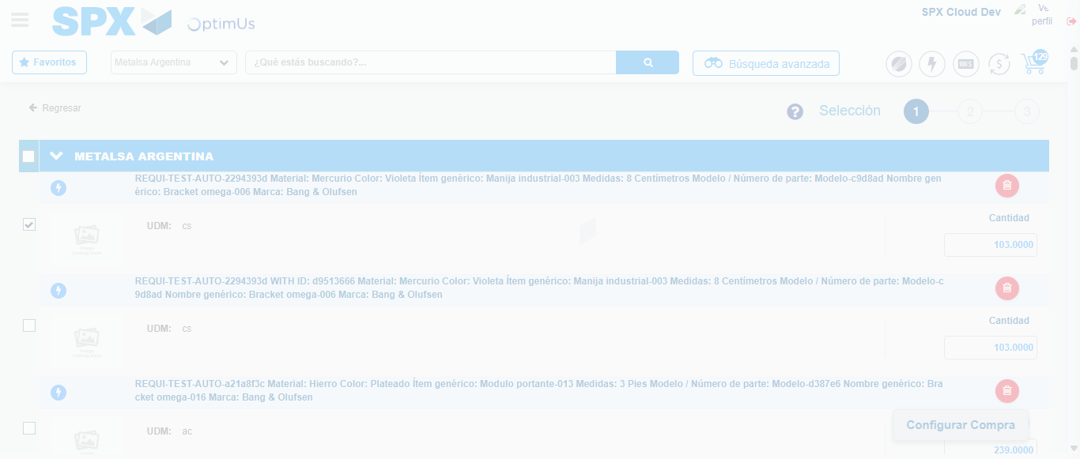Image file-name: QC_Testing-tc001_SPX_Dev5_Crear_Nueva_Linea_Requisicion_Spot_Tipo_Cobro_CC-nov. 27 2025, 07 12 33 p. m.

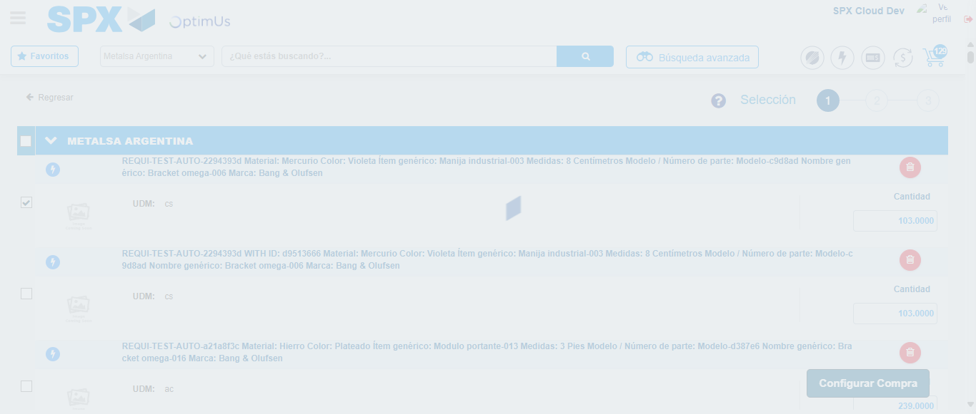Image file-name: QC_Testing-tc001_SPX_Dev5_Crear_Nueva_Linea_Requisicion_Spot_Tipo_Cobro_CC-nov. 27 2025, 07 12 38 p. m.

Step 6 - Select Type Account For Requisition: Type Account Correctly selected
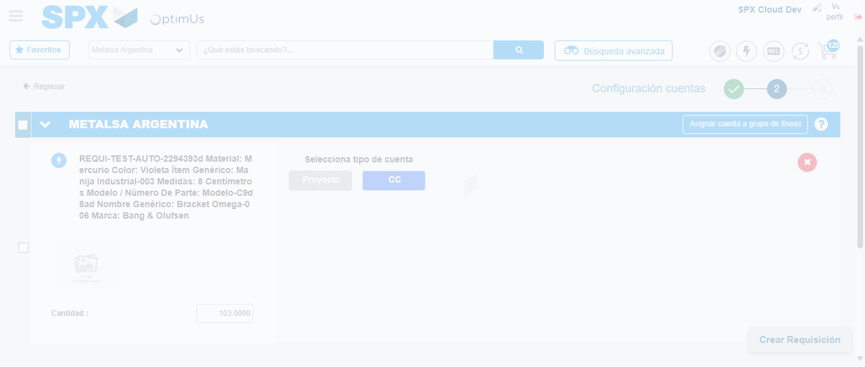Image file-name: QC_Testing-tc001_SPX_Dev5_Crear_Nueva_Linea_Requisicion_Spot_Tipo_Cobro_CC-nov. 27 2025, 07 12 41 p. m.

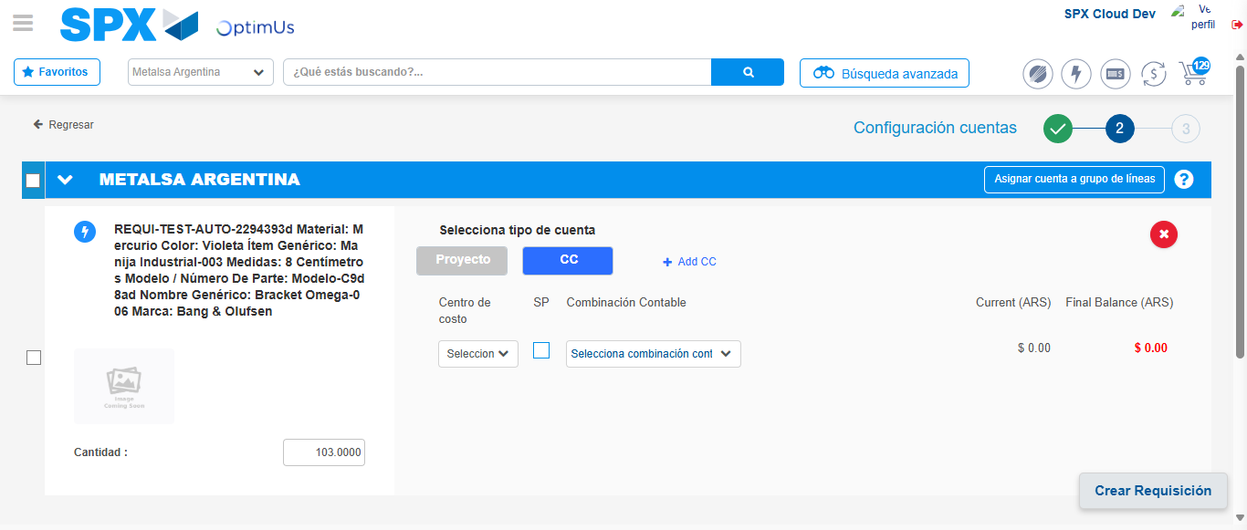Image file-name: QC_Testing-tc001_SPX_Dev5_Crear_Nueva_Linea_Requisicion_Spot_Tipo_Cobro_CC-nov. 27 2025, 07 12 44 p. m.

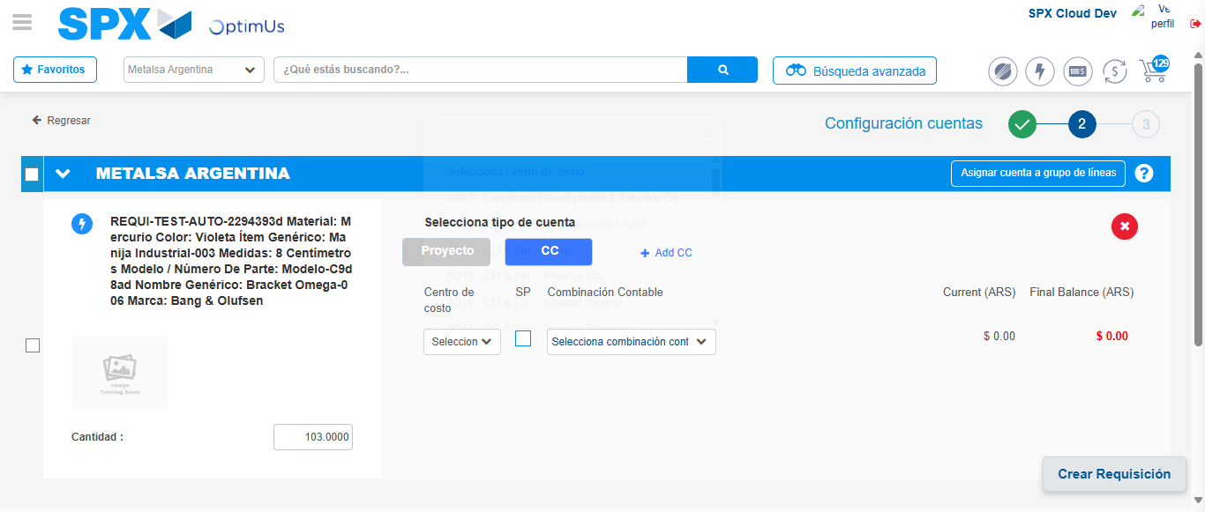Image file-name: QC_Testing-tc001_SPX_Dev5_Crear_Nueva_Linea_Requisicion_Spot_Tipo_Cobro_CC-nov. 27 2025, 07 12 47 p. m.

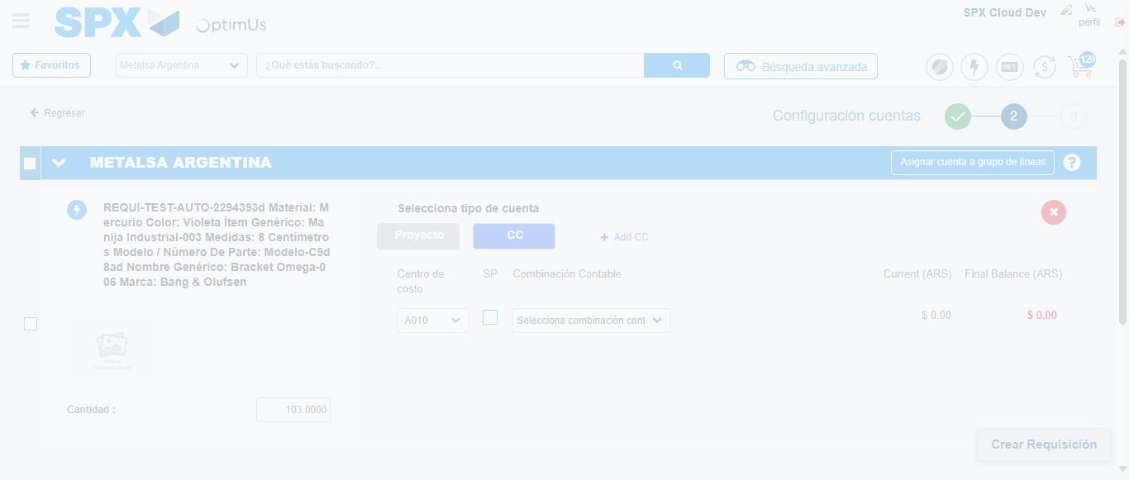Image file-name: QC_Testing-tc001_SPX_Dev5_Crear_Nueva_Linea_Requisicion_Spot_Tipo_Cobro_CC-nov. 27 2025, 07 12 48 p. m.

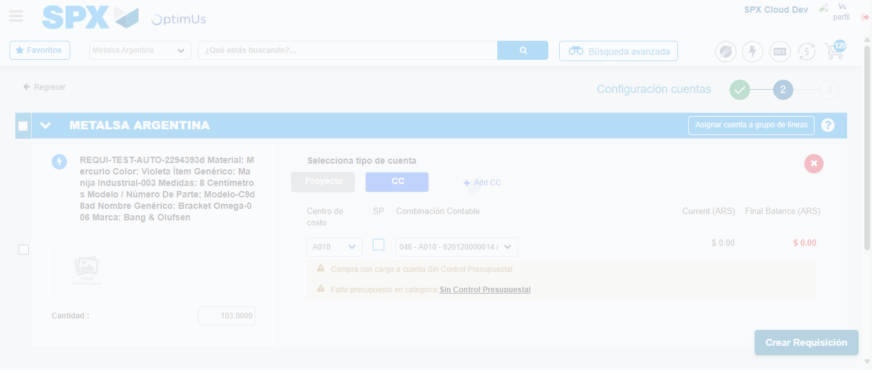Image file-name: QC_Testing-tc001_SPX_Dev5_Crear_Nueva_Linea_Requisicion_Spot_Tipo_Cobro_CC-nov. 27 2025, 07 12 51 p. m.

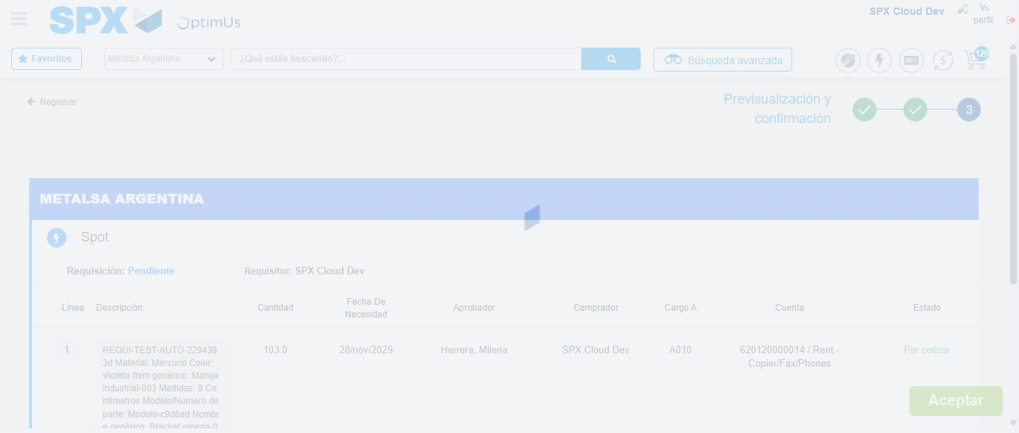Image file-name: QC_Testing-tc001_SPX_Dev5_Crear_Nueva_Linea_Requisicion_Spot_Tipo_Cobro_CC-nov. 27 2025, 07 12 52 p. m.

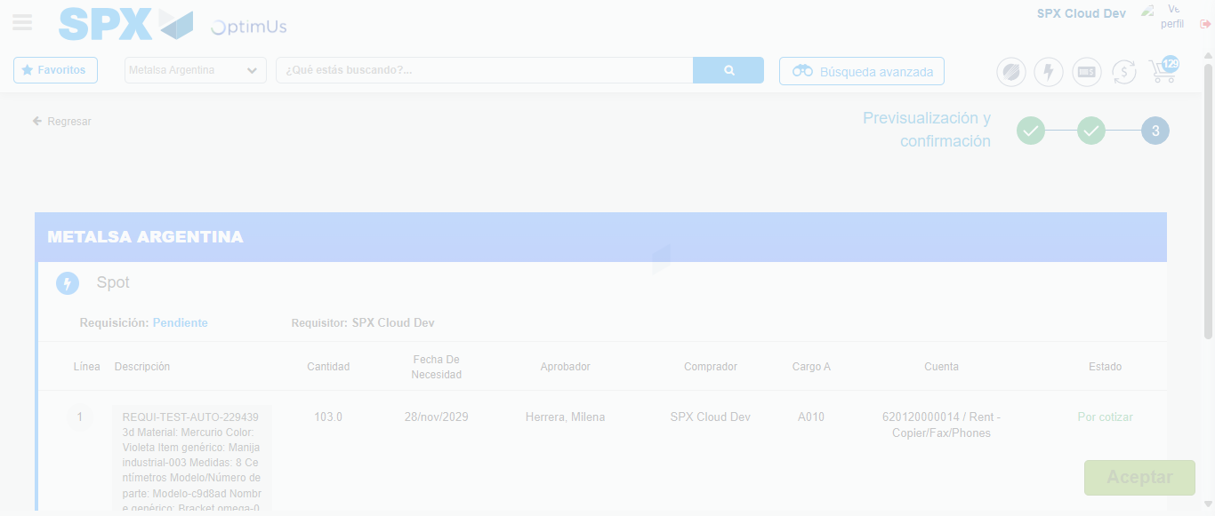Image file-name: QC_Testing-tc001_SPX_Dev5_Crear_Nueva_Linea_Requisicion_Spot_Tipo_Cobro_CC-nov. 27 2025, 07 12 55 p. m.

Step 7 - Accept to Requisition: Requisition Accepted
Image file-name: QC_Testing-tc001_SPX_Dev5_Crear_Nueva_Linea_Requisicion_Spot_Tipo_Cobro_CC-nov. 27 2025, 07 12 55 p. m.

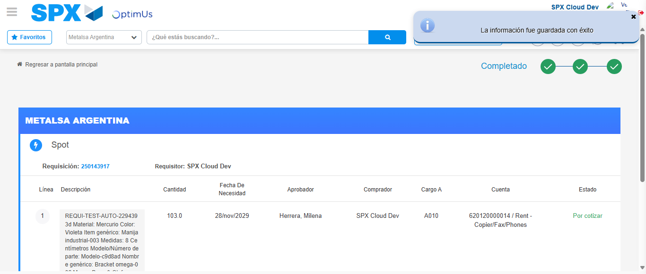Image file-name: QC_Testing-tc001_SPX_Dev5_Crear_Nueva_Linea_Requisicion_Spot_Tipo_Cobro_CC-nov. 27 2025, 07 12 59 p. m.

